BSHM December meeting – Saturday 9th December 2017.

Central Birmingham remains in the middle of a major reconstruction programme in almost all departments and matters change on a daily basis! If you are new to central Birmingham, it would be folly to attempt to drive in the centre without considerable pre-planning. The now rebuilt and otherwise hugely impressive New Street Station concourse has poorly signed pedestrian exits and it is easy to get lost. Further, those regulars, familiar with the route on foot to the BMI via Victoria Square, may find that this is now blocked. PLEASE LOOK CAREFULLY AT THE ADVICE IN BOLD BELOW.

The following should assist you in finding and accessing the venue; this is at
The Birmingham and Midland Institute (BMI), 9 Margaret Street, Birmingham, B3 3BS
0121 236 3591– website http://bmi.org.uk/ .

By Train and Walk.

This is by far the easiest way to get to the BMI, which is ten minutes from New Street Station.

Exit the station at the New Street exit. This is now signed in rather small yellow text on the blue boards. This puts you out onto Stephenson Street. Do not go out of the main station exit – this is diametrically opposite where you need to go and it is difficult to recover that ground. Much building work is still going on. From Stephenson Street walk up to New Street via Temple Street or Corporation Street, turn left, and go up New Street towards Victoria Square. At this time of year you will need to run the gauntlet of the Birmingham ‘Frankfurt Market’, which consists of numerous small temporary shops/stalls all along your route. There may well be quite a lot of people on your return in the evening as the market is very popular – and rather fun! Then Turn Right, off New Street, into Bennet’s Hill. Walk to the top of the hill, crossing Waterloo Street. Turn left down Colmore Row towards Victoria Square and the Council House. Just before you reach the Council House, turn right down Eden Place then, turning left and immediately right, enter Margaret Street. You will pass on the right ‘the School of Art’, a magnificent terracotta building, and next to it is the BMI, another terracotta building. Once inside you will be directed - but in case not, the lecture theatre with Registration is downstairs and coffee will be upstairs on the right.

By Car and Walk

There is no specific BMI parking as it is situated in the city centre. If coming by car you will hopefully know the area and will need to take your chances for parking. Despite it being Saturday, parking is still charged for and ‘on the street’ can be most expensive. The link below gives details of all the car parks in range.
http://en.parkopedia.co.uk/parking/near/birmingham-and-midland-institute-and-conference-centre/

It is suggested that you will find ‘Snow Hill’ Station (11 on the parking map) the most convenient. Do not try to get south of the city centre from the north. Navigation in the city centre is most difficult, even for locals, and jams may occur, so please do plan in advance. Your Sat Nav will almost certainly lead you very astray!

There are a few unlimited disabled parking bays right outside the BMI on Cornwall Street.

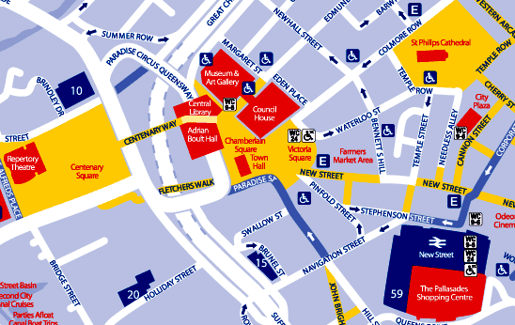

Finally.

This meeting is open to all at a flat rate of £25 (£35 non-BSHM/BMI members) including buffet lunch. BSHM has introduced a subsidized Under 25 years young person rate for meetings. This time the rate is £15. Please feel free to bring any friends with you. Please book them in via Eventbrite as directed on our website.

We have a good programme with distinguished speakers and it should be a very good day.

If you have any questions at all, please don’t hesitate to contact me on bshm1@lagonda.org.uk
Richard Simpson, BSHM.

